Policy Brief - Vol 1
Authors: Zoneziwoh Mbondgulo-Wondieh, Ph.D, Agbor Rita, Ndefon Beatrice, Rosette Leinyuy, Hope Akenji, Tarhyang Enowbikah Tabe, Frida Baiye, Emma Lebaga & Mukom Leonard

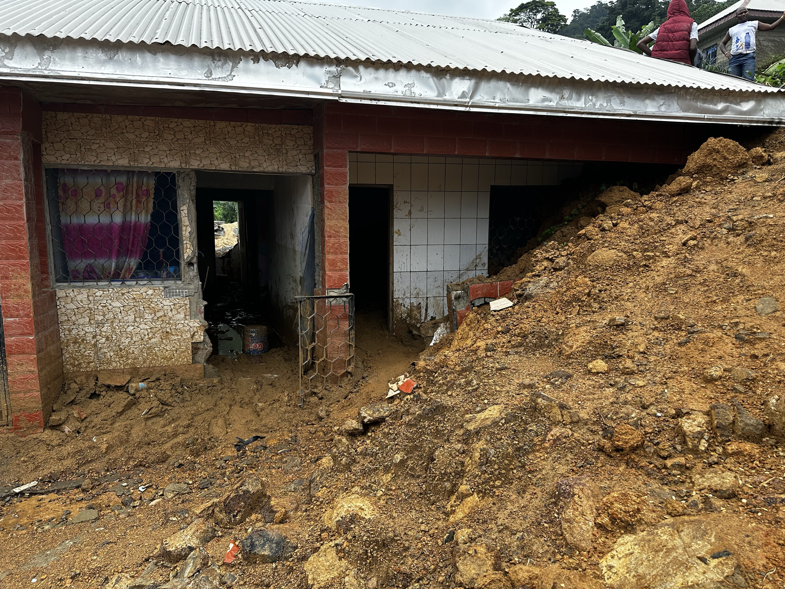
Mawoh Women’s Policy Recommendations on the Limbe Flood Evacuation Plan
Introduction
In July 2023, the world woke up to the devastating effects of climate change in Limbe city, particularly in Mowoh, Lower Mowoh, Southeast Community and Cassava Farm and others were all covered with flood and muds resulting in thousands displaced persons, including deaths and loss of properties. Reports indicated that the neighbourhoods' worst affected during the July flood were, Church Street (700 people), Mawoh (400 people) and Down Beach (500 people), making a total of about 1,600 people directly affected by the flooding (Humanitarian Relief, 2023). The flooding was largely due to run-off water and unplanned construction, which prevented water from circulating normally. Other damage included the destruction of goods in shops, and more seriously, the suspected disappearance of an adult, 05 people injured and 02 dead. (IFRC, 8 Aug 2023). As a government’s response, a radio announcement released from the Limbe City council of July 20, 2023 by the Lord Mayor Mr. Paul Ngale, advised residents in the affected areas to evacuate with immediate effects and cautioned about an emergency evacuation plan and action was to be executed.

Months later, residence of the areas are still recovering from the flood. Many still suffer from the effects of that catastrophe. With the majority of the victims being women and girls. For, it is evident that people who are already most vulnerable and marginalised will also experience the greatest impacts. To that effect, the poor are expected to be disproportionately affected and consequently in the greatest need of adaptation strategies in the face of climate variability and change.

Gaston (2009) researched and found that in the Limbe Subdivision of Cameroon, landslides and flooding are frequent threats. Citing the worst recorded event occurred in June 2001, when floods and landslides took the lives of some 30 persons, left over 2000 people homeless, and destroyed property and social amenities including roads and telephone lines worth hundreds of thousands of US Dollars.

This project is a joint project co-led by GenEgaliteECCAS, Solidarity Health Foundation, ASOMEF, Women for a Change, MIFALI. Supported by Urgent Action Fund, Africa.

Methodology
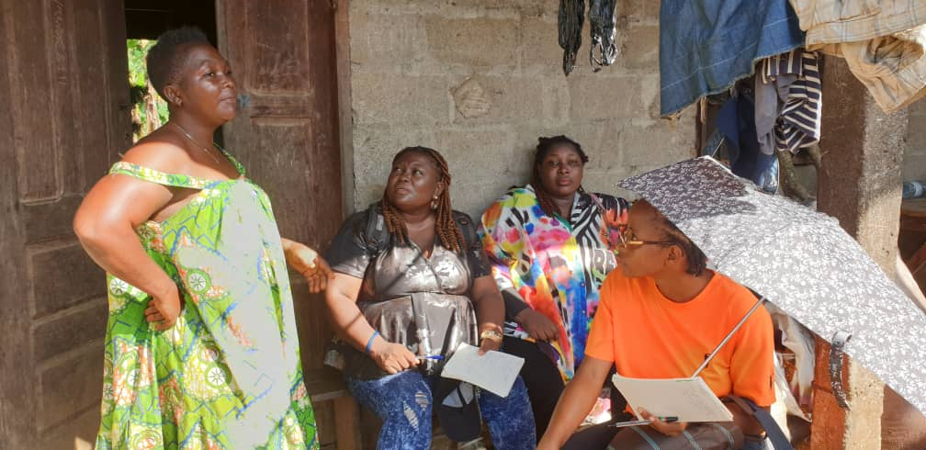
This project was conducted following an emancipatory and participatory approach, involving visitations, focus group discussions, outreaches and mediatisation. With focus groups held among 43 female residents of Mawoh. Participants were randomly and purposefully sampled based on their residence, age, experience and years of living in those affected areas. Worthy of note is the fact that prior to conducting the focus group discussion which took place in November 2023, between July and Octobers, door – to - door consultations and visits was made to some 100 women, from which 43 of them were invited to be part of the focus group discussion. The morning of the flood, members visited the hospital and supported in cleaning and removing of water in flood hospital maternal wards. They also provided sanitation kitssuch as sterilisers and hand sanitisers, sanitary pads and products. Participants names used in this brief have been anonymised.
Findings
The focus group discussion was conducted with 43 women residing in Mawoh affected by the recent landslide. The purpose of the discussion was to gather their perceptions and recommendations regarding the evacuation plan suggested by the Lord Mayor of Limbe. The women shared their motivations for coming to Mawoh, which included reasons such as family, marriage, cheap accommodation, business opportunities, cheap land, and fertile soil. However, they expressed regrets over issues such as theft, landslides, and bad roads.

Constance (33) alluded that the motivation of moving to Mawoh with her family was because of the low cost of leaving and cheap land. Though many might have moved to this community due to economic reasons, amidst the insecurities, the recent landslide as narrated by many, has had various impacts on the women. They reported feelings of fear and anxiety, lack of access to water, difficulties in sleeping, loss of tenants, and poor road conditions.

When asked about evacuating the area as a solution, four of the twenty-five women shared that it would be beneficial if they had the means to relocate and if the government could provide alternative housing. However, the majority of the women (35) disagreed with the idea of evacuating the zone.
“Though my whole back yard was already filled with land, the water still entered through the back yard to my parlour and rooms…”, said Monica, 35 years old, However, “I don’t see myself moving after investing so much here. I think if I have bit of money, I will rather build a wall at the back so that water won’t enter the house in case of flooding again”

According to another eyewitness lady living in the Mowoh area, during the landslide incident, all the women were at home except for six whose husbands were absent. The women mentioned losing personal belongings such as clothes and mattresses, farming tools, animals, as well as experiencing damage to their houses.

And since the event occurred, two of the women confirmed that they have being invited to meetings since the landslide occurred. One was invited by the mayor and another by the church.

However, all 43 women acknowledged the potential risk of landslides in Limbe. And were interested in undergoing through trainings on emergency crisis or information regarding evacuation procedures in the event of a landslide and / or flood. The lack of suitable accommodation options was identified as a barrier preventing them from leaving the landslide-prone area. Additionally, none of the women were informed about the actions taken by local government authorities to address the landslide issue. Some women had taken personal initiatives to redesign their homes by building embankments.

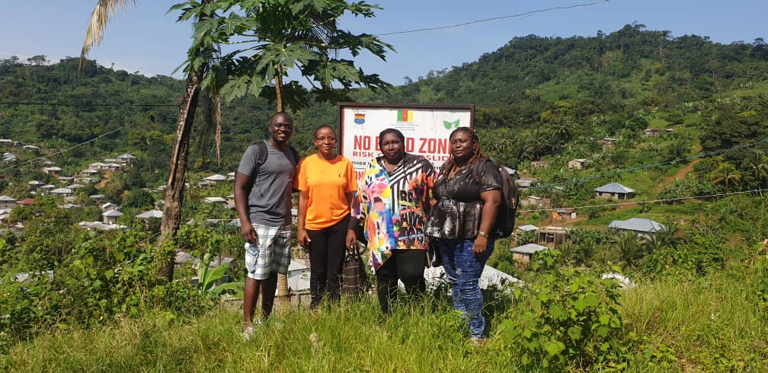
Recommendations
With the increasing effects of climate change being felt every day across the country, a comprehensive, effective, efficient, and equitable climate change planning and preparedness is paramount. From the focus group discussions, the following are the recommendations shared by the women and girls who participated in the interview. This recommendation is for our decision makers and municipality.

Guaranteeing inclusive decision making and meaningful participation at all levels: Ensuring that the women of the flood affected communities are involved in all decision making processes related in the designing, development, implementation and evaluation of the evacuation plan, including meaningful participation at the community-level too.

Mainstream gender in all actions related to the management, mitigation and adaptation plans for Limbe Flood: Gender mainstreaming does not merely imply
a one-off solution to issues of equity and equality by adding women’s participation to existing strategies and programmes. Rather, it seeks to transform unequal societies and institutional structures to realise the full creative and productive capacity and potential of women to reduce vulnerability and enhance efficiency and effectiveness of development projects and programmes. This typically demands capacity building on gender mainstreaming across a range of stakeholders, so that the end goal of more just and equal societies can be fully understood and owned by all stakeholders.

Evacuation plan must address women and girls sexual and reproductive health rights: An evacuation process is generally very stressful. Families at this time may have to stop all business activities and so as to take care of their properties and families. If the plan is to take a longer period, temporary shelters, clean water are to be made or volunteers sorted to take care of families for the period. And through out these processes, women and girls therefore need to be provided with the necessary sexual and reproductive health services and products such as sanitary pads and dignity kits. This should not exclude Pregnant women and nursing mothers as well as persons with special needs.
Early warnings on flood occurrences should be communicated to the “Town criers” on time: There is a need to bring the services of town planners and town criers who would advise and inform the people ahead of floods including the landlords.
Capacity Development and Strengthening of community leaders on emergency response: The town criers and planners including the women and community leaders should be trained on emergency response at times of emergency humanitarian crisis. This training also could include training with house owners on how to protect their houses, how to build resistant houses in this area and also the nature of houses to be built in this area.
Organise town halls meetings and public campaigns, including continuous cleanup campaigns of the drainages and poor waste dumping sites: he town hall meetings and community cleanup campaigns should rally young people to educate them on the need to pick up plastic papers and bottles which have been deposited or thrown away along the streets and gutters and can be the main cause of floods.
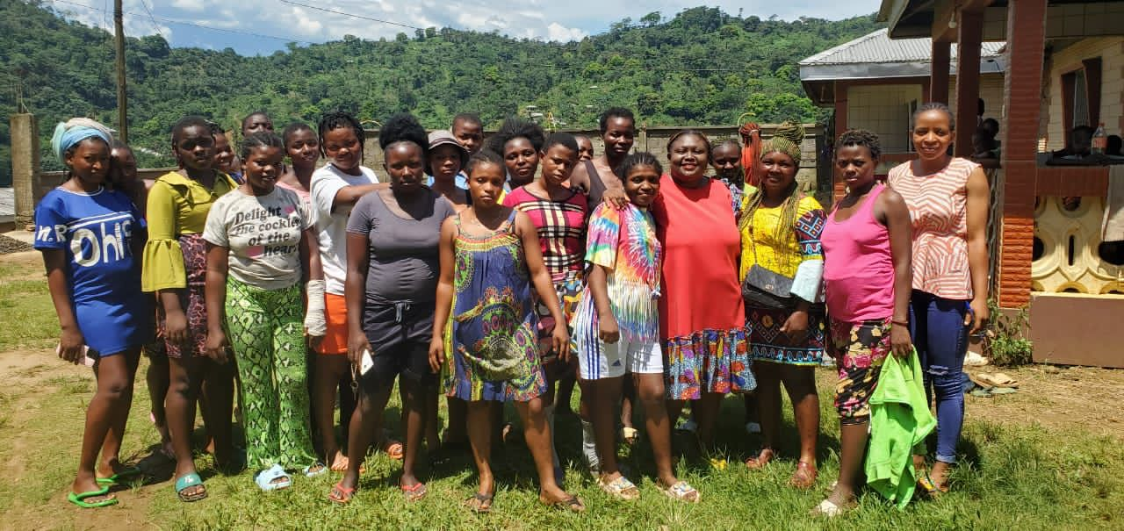

References

Ayonghe, S.N., Mafany, G.T., Ntasin, E., and Samalang, P. (1999). Seismically activated swarm of landslides, tension cracks and rockfall after heavy rainfall in Bafaka, Cameroon. Natural hazards
Gaston B Wung (2009) Geographic information systems based demarcation of risk zones: the case of the Limbe Sub-Division – Cameroon https://pdfs.semanticscholar.org/2d32/e6b24d87d9cd31b9baf8e4413bf59793d880.pdf accessed November 1, 2023

Humanitarian Response Relief, https://www.humanitarianresponse.info/en/disaster/fl-2023-000135-cmr accessed November 8, 2023

Ngale, P. (2023) ‘Radio announcement’. Limbe, Southwest region: Limbe City Council.
Relief Web https://reliefweb.int/node/3987701 accessed November 1, 2023

World Weather Attribution https://www.worldweatherattribution.org/climate-change-exacerbated-heavy-rainfall-leading-to-large-scale-flooding-in-highly-vulnerable-communities-in-west-africa/ accessed November 8, 2023

Zogning, A. (2001), La Catastrophe du 21 Juin 2001 à Limbé. Rapport Scientifique MINREST/INC/DRG accessed November 9, 2023

